GROUP STUDY ROOM RESERVE LOG PRINTING INTRUCTIONS
Ref desk Printer
- To print this document; choose the printer \\board\LR219-LJ2600 (Ref desk) Click on the properties button.
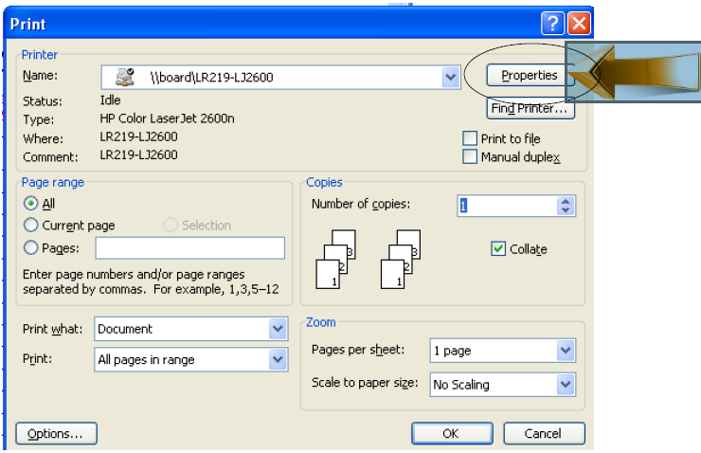
- On the “Paper/Quality” tab, size is: legal
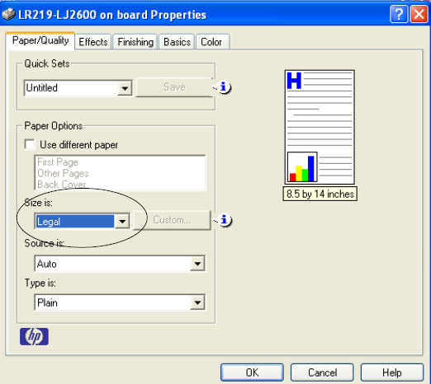
- On the “Finishing” tab check “Print On Both Sides” and check “Flip Pages Up” and click on “OK.”
- Back on the main printing dialog box, put in the number of copies and then hit “OK.”
- Printing Tips

•Be sure to use legal size paper.
•Remove the bottom paper tray
•Push the blue button in the back of the
paper tray and slide the tray back to the
legal size setting.
•Flip the paper manually to print the other
side. (Face Down)
•Be sure to mind the paper at the printer to
keep it from jamming.

