You are invited!!!

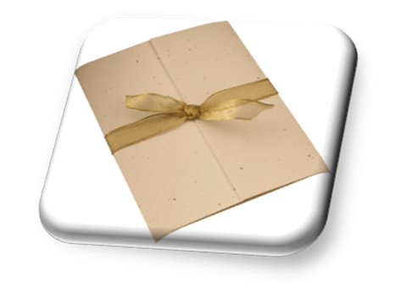

**The year-end Get-together is on: Wed, May 18th,   
In the LAC Conference Room**

**11am – 1pm**

C:\Users\pcclibrary\AppData\Local\Microsoft\Windows\Temporary Internet Files\Content.IE5\2SJ2QJUN\MC900089738[1].wmfC:\Users\pcclibrary\AppData\Local\Microsoft\Windows\Temporary Internet Files\Content.IE5\2SJ2QJUN\MC900089738[1].wmfC:\Users\pcclibrary\AppData\Local\Microsoft\Windows\Temporary Internet Files\Content.IE5\2SJ2QJUN\MC900089738[1].wmfC:\Users\pcclibrary\AppData\Local\Microsoft\Windows\Temporary Internet Files\Content.IE5\2SJ2QJUN\MC900089738[1].wmfC:\Users\pcclibrary\AppData\Local\Microsoft\Windows\Temporary Internet Files\Content.IE5\2SJ2QJUN\MC900089738[1].wmfC:\Users\pcclibrary\AppData\Local\Microsoft\Windows\Temporary Internet Files\Content.IE5\2SJ2QJUN\MC900089738[1].wmf