Catalog Practice Exercises
Library 1, Assignment #2 Name_______________________
Learning Goals: Become familiar with the basic concepts, vocabulary and use of the Library Online Catalog to find relevant items. Demonstrate an understanding of keyword search options, advantages and disadvantages and the need to evaluate results.
Instructions: Locate The LBCC Library Online Catalog located on the LBCC library homepage: http://lib.lbcc.edu/. Complete the following searches using The LBCC Library Online Catalog.
Click on Advanced Search, then type the author’s name in the box next to author.
Author search:
Select an author from the list below. Provide the citation information for any one book:
Henry James Maya Angelou Elie Wiesel Gabriel Garcia Marquez
Maxine Hong Kingston William Shakespeare Edgar Allan Poe Yasunari Kawabata
Write your search strategy (what did you type in the search box?) _________________
Author(s) of the book: _________________________________________________
Title of Book: ____________________________________________
Publisher: ____________________________Publication Date:________________
Call #: ___________ Location: _____________ Status: ____________________
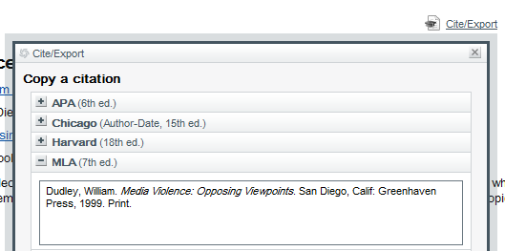
MLA format hint:
When you click on an item in the catalog, look for the Cite/Export button at the top of the page.
Click on the + button to the left of MLA, to display the MLA format.
Click on Advanced Search and then type the title of the book in the box next to “title”.
Type in the title name
Title search:
Select a book from the list below and provide the citation information:
An American Tragedy The Sun Also Rises The Joy Luck Club A Mind of Her Own
The Great Gatsby The Old Man and the Sea Catch-22
Write your search strategy (what did you type in the search box?) _________________
Author(s) of the book: _________________________________________________
Title of Book: ____________________________________________
Publisher: ____________________________Publication Date:________________
Call #: ___________ Location: _____________ Status: ____________________
The MLA format for a book is:
Last name, First name. Title of Book. City of Publication: Publisher, Year of Publication. Medium of Publication.
Write the bibliographic citation for this book using the MLA format.
____________________________________________________________________________________
______________________________________________________________________________
______________________________________________________________________________

Click on Advanced Search, then select “subject from the drop down list. Next type the subject in the box next to “Subject”.
Type in the subject
Subject search:
Select a subject from the list below and answer the following:
gun control air pollution jazz drug abuse political science abortion
cyber-crimes Internet accounting Presidential elections quantum theory
Subject Picked: ______________________________Number of Items:________________
Are there any related subjects? Yes __ No __. If Yes, select one link and follow it.
Which link did you click on? _____________________. Is this helpful? ________________
Choose one book on this subject. Author(s) of the book: __________________________
Title of Book: ____________________________________________
Publisher: ____________________________Publication Date:________________
Call #: ___________ Location: _____________ Status: ____________________
The MLA format for a book is:
Last name, First name. Title of Book. City of Publication: Publisher, Year of Publication. Medium of Publication.
Write the bibliographic citation for this book using the MLA format.
____________________________________________________________________________________
______________________________________________________________________________
______________________________________________________________________________
Course Reserves
Use Course Reserves to look for items on Reserve for a class, such as a textbook.

Type in one course name, and then hit search.
Example Search

Course or Reserve Item you searched for: ______________________________________________
List the title of one item on reserve: ______________________________________________
Call # ____________ Location: ____________ Status: ___________________

Keyword Search
Click on Advanced Search, then select “Keyword from the drop down list. Next type the subject in the box.

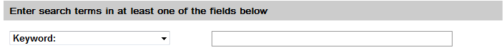
Type in the keyword

Example Keyword Search using Advanced Search
: _______ Presidential elections

: __________ history__________

Choose any of the following topics and use Keyword Searching to complete two separate searches.
Topics of choice are:
social media and teenagers media violence and rap stem cells and development
obesity and children violence and guns Presidential elections and history

For each search, follow these steps: 1.Using advanced search again, change the drop down menu to “keyword” 2.Type in your search words, 3.Complete the MLA citation information for one book.

Keyword Search #1
: ___________________________
: ___________________________
List one book: Author of the book: ________________________________________________
Title of book: _____________________________________________________
Publisher: ______________________________Publication Date ____________
Call #: ________________ Location: __________ Status:_________________
Write the bibliographic citation for this book using the MLA format.
____________________________________________________________________________________
______________________________________________________________________________
______________________________________________________________________________
Keyword Search #2
: ___________________________
: ___________________________

List one book: Author of the book: ________________________________________________
Title of book: _____________________________________________________
Publisher: ______________________________Publication Date ____________
Call #: ________________ Location: __________ Status:_________________
Write the bibliographic citation for this book using the MLA format.
____________________________________________________________________________________
______________________________________________________________________________
______________________________________________________________________________

