What is a call number?  A call number is like an address; it tells you where the book is located on the shelf. Each book has its own unique call number which is usually located on the book's spine. | Call numbers appear:  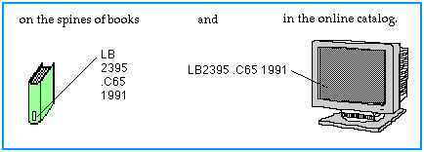
Reading Call Numbers  LBCC uses The Library of Congress numbers in the Library. This system arranges materials by using a combination of letters and numbers. The first section of the call number represents the subject of the book. The second section often represents the author's name, and the last section is the date of publication. | 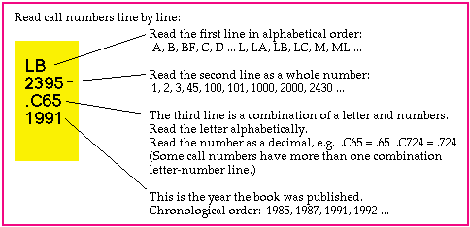

To locate your book on the shelf, you must look at each section of the call number.  Start by reading the first line in alphabetical order. B comes before BC.  Next read numbers that come after the letters are read as whole numbers and are arranged numerically on the shelves. | 